Tabs
- Home
- Support Desk [Instead of Emergency]
- Contact Us [Instead of team/directory]
- Gallery
- Self-Check Up [For the check up related website]

Home
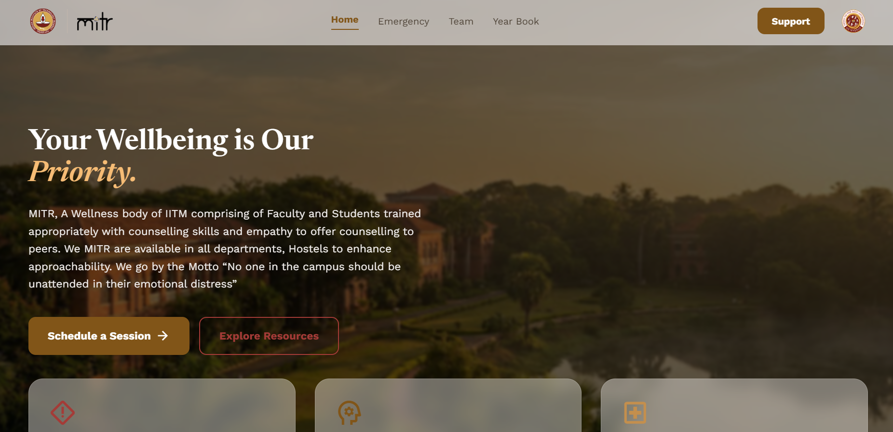
- Logos can be made more larger, top line of logos
- Front running pictures can be happy faces, game stalls, fun pictures, from our event

Your Wellbeing is Our Priority
V1: MITR, is a Wellness body of IITM, run by the students, for the students, to deal with all sorts of mental, emotional, wellbeing issues that the students go through in their daily activities. We MITR are available in all departments, Hostels to enhance approachability. We go by the Motto “No one in the campus should be unattended in their emotional distress”

Your Wellbeing is Our Priority
V2: MITR, A Wellness body of IITM comprising Faculty and Students trained appropriately with counselling skills and empathy to offer counselling to peers. We MITR are available in all departments, Hostels to enhance approachability. We go by the Motto
“No one in the campus should be unattended in their emotional distress”

- Mitr motto can be brought after this
  - In need and indeed for you

- The support section on top right corner can have all the emergency contacts needed as a drop down menu, call sos part can be utilised here. Add some MITR contacts also
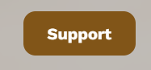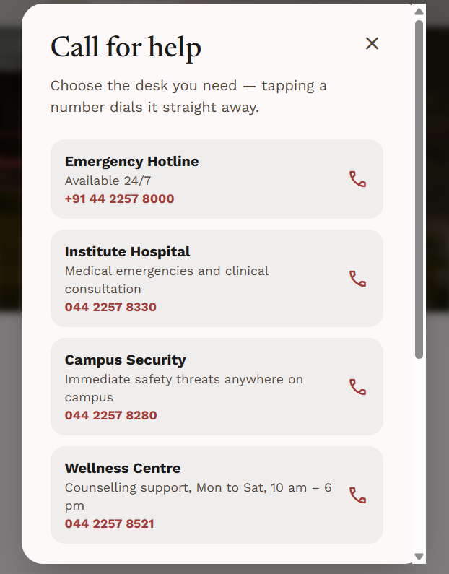

- Check your emotional wellbeing / Self Assessment Test, either one [Instead of Check In With Yourself]
  - An anonymous, 2-minute check-in, based on clinically validated mental health questionnaire to help you understand different aspects of your wellbeing better.
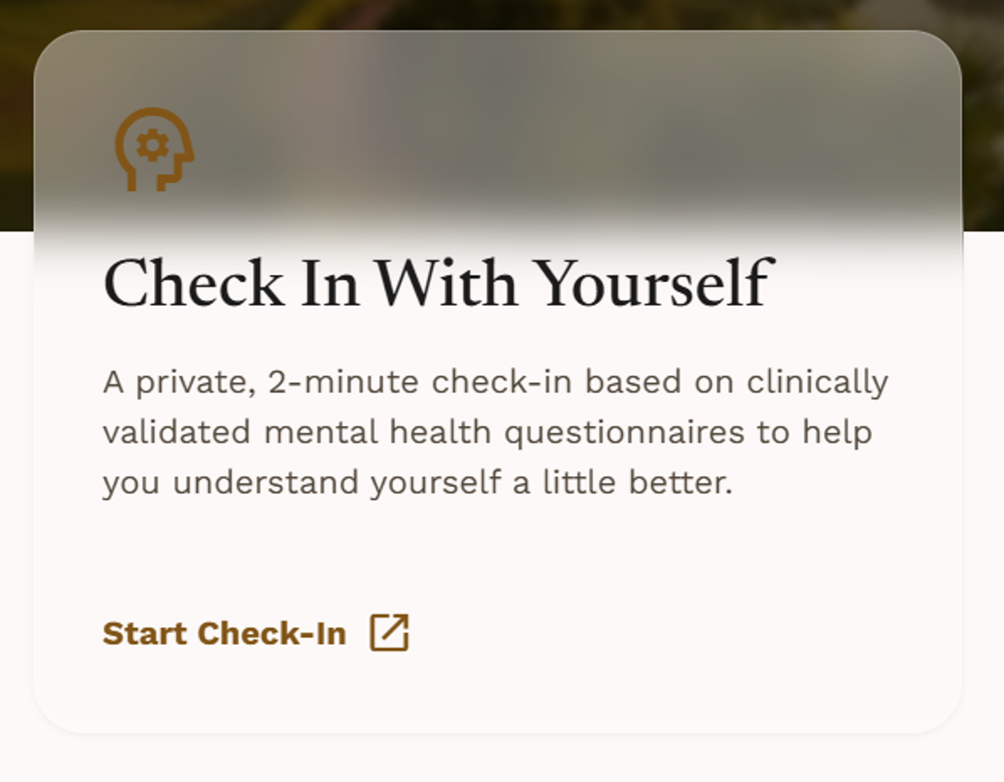
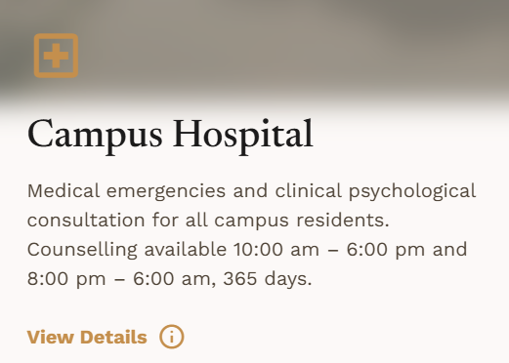

- Format this in a better way, Align the timing to center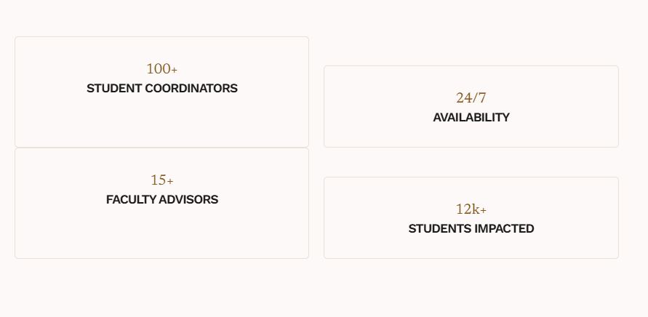
- Highlight this more

- Remove the nirf ranking and use that space to put up the different counselling facilities available in brief
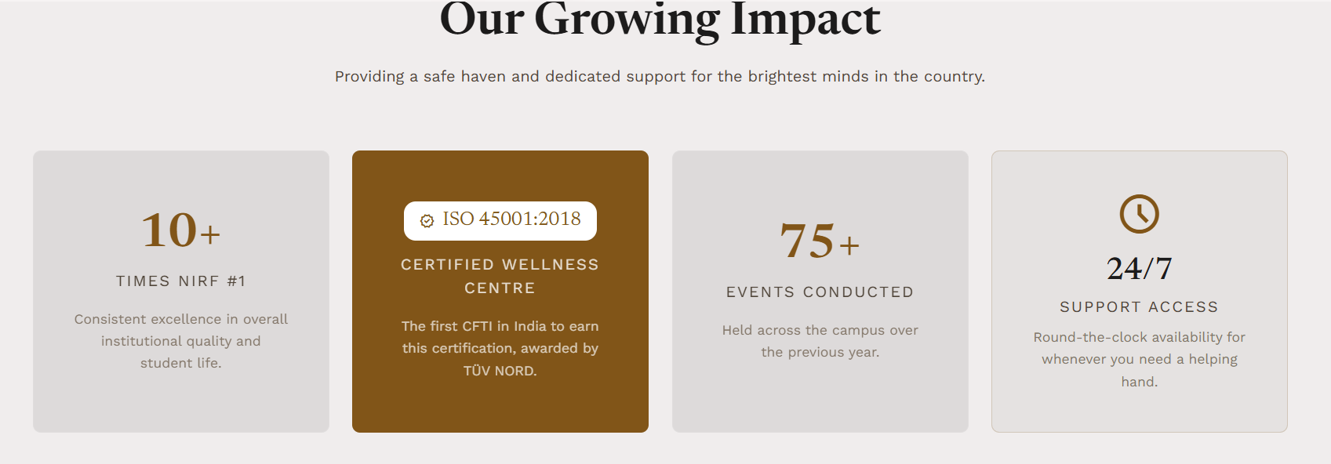

  - Peer Counselling System [Instead of Integrated Peer System]
    - Student coordinators are trained under medical professionals to ensure an appropriate approach to counselling
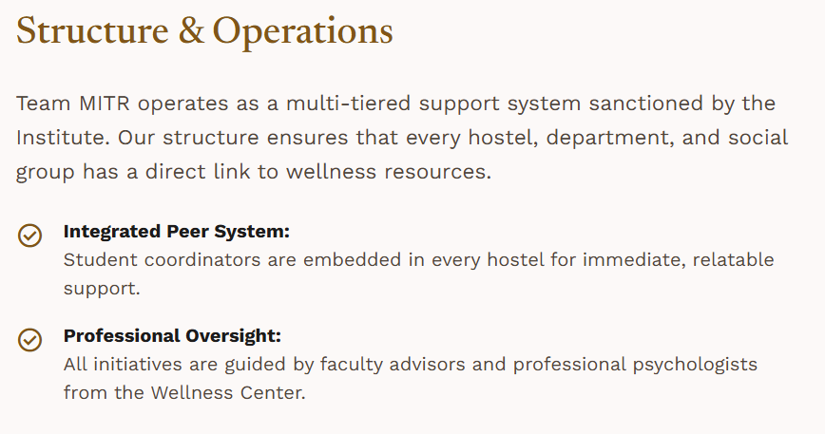

- All about MITR section needs to be updated

Change this ”MITR is guided by our Dean of Student Prof. Sathyanarayana N Gummadi, Wellness Advisor Prof. Sarith P Sathian, Our Associate Dean (Wellness) Prof. Suresh Kumar Rayala and Wellness Officer Col. Balaji.

MITR team members are recruited every year in a very tedious manner. Applicants are screened and sorted via interviews. To ensure availability in each department, A student from each department and Hostel is recruited and are given barefoot training. The following is the Team’s vertical leads”

to

”MITR is guided by Our Dean of Student Prof. Sathyanarayana N Gummadi, Wellness Advisor Prof. Sarith P Sathian, Associate Dean (Wellness) Prof. Suresh Kumar Rayala and Wellness Officer Col. Balaji.

MITR team members are recruited every year in a multi layered manner. Applicants are screened via their applications and then sorted via interviews. To ensure our availability across the campus, A student from each department and Hostel is recruited and is given essential training.

- Random positive message generator, can be added?
- Talk to a mentor, where does it lead to?

Support Desk [Instead of emergency tab]
- The word “Crisis” can be removed

- Mitr Helpdesk,
  - Peer-led support for emotional well-being and navigating through difficult times.

- Format this in a better way, Align the timing to center
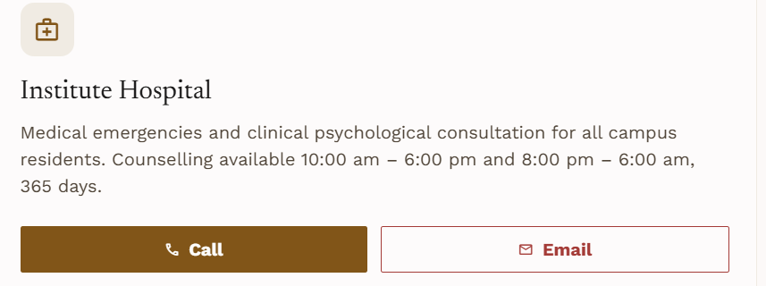

- Swap the wellness centre and security section
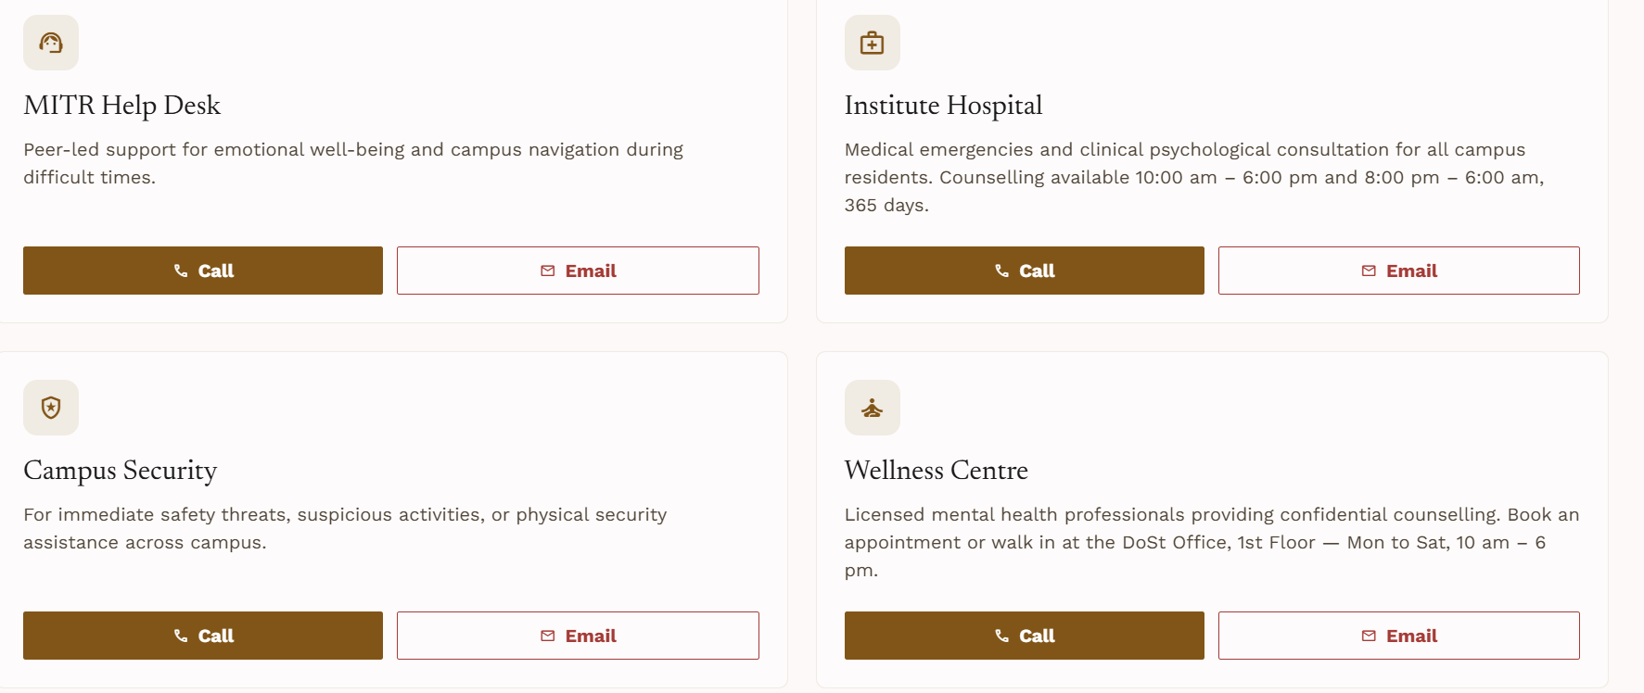
Align the timing in wellness centre description to center as well

- Highlight that YourDost is available both online and offline for counselling
- 100% Confidential can be made more visible, better highlighted, blinking or something
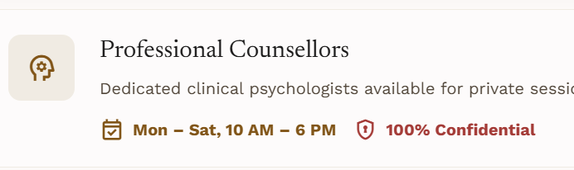
- What all needs pre booking and all can be easily mentioned, what all can be done as walk-in should be highlighted. Yourdost needs some pre booking. Insti hospital does not need that, it should be highlighted.

Contact Us
- Where the contacts of all mitr, based on hostel, department, language, can be selected.
- Book a coffee with MITR Addition
  - Maybe build an automated system where once the peer counsellor is selected it sends an email to the mitr email alerting us.

- Hostel coords, dept coords, no need for separation as such

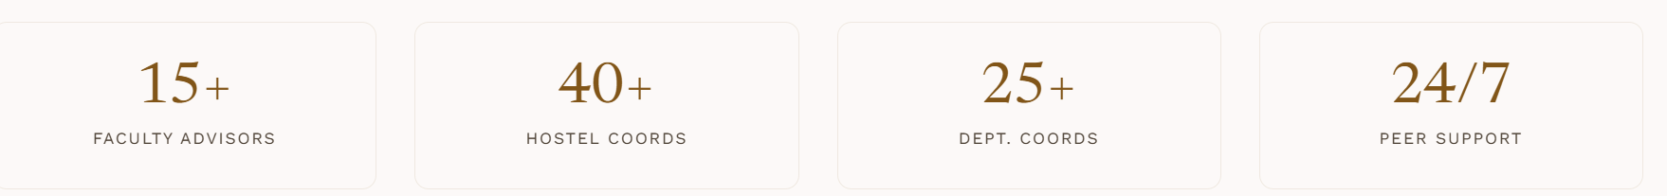

Gallery
- Yearbook can be shared there
- Have more running pictures in bg, student experiences from the events can be added
- The events button can lead to the events report
- What is the media kit meant to be?
- All the buttons at the bottom of page like privacy policy stuff lead no where so better be removed imo.
- We don't have a login section as well so better remove the login window on top right entirely

Additions
- Sticky Notes based experiences [In wellness centre lot of sticky notes people have written, so adding some real photos will help]
- Student experiences
  - Some experiences, notes from students...let people think it is fake or not. Anyways put it. Different languages, different problems, different solutions
- Department wise, hostel wise professional counsellors are available, and link can be given to pdf schedule, or link to book a slot
- Brochure can be added as well

